Introduction to Turing

Turing is a program language which you can use to create programs to perform different action on the computer.

Getting Started

To open the Turing program:
Start → Program → Turing
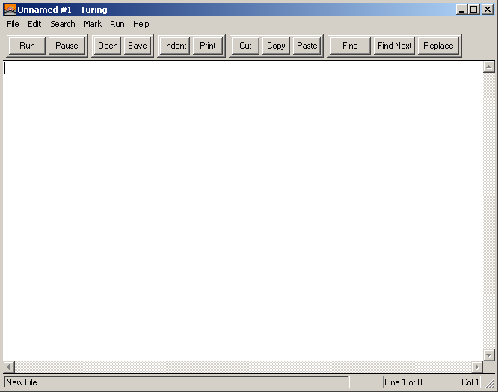
Area where you type in your program
Menu bar to perform standard action such as “Open, “Save”
Click here to run your program

Simple One-Line Programs

put -A simple command to output text. This command is used anytime you want to display characters in your program. “ ” – specified the string to be printed out

Type the following code:

ex. put "Hello, everybody."

Click “Run” and see what happens.

Note that a program must follow the syntax of the language. For example, in Turing, put is used to output on the screen. Any string to be output must be surrounded by quotes.

Screen output

- displaying characters on the screen (numbers, letters, special characters, spaces etc)
- formatting the information eg. tabs, line breaks, number of decimal points etc.

Displaying literal strings
Literal string: a series of characters in quotes

Examples:

Code | Output | Notes
put^”Hellothere^bobby251!” | Hellothere^bobby251! | literal duplication
put^”The^answer^is:^^” | The^answer^is:^^ | non letters ie “:”
put^”abc”:10 | abc^^^^^^^ | field width
put ^”\tThe^answer\nis:” | ^^^^^^^^^^The^answer  is: | control characters (\)
Note:
- the string is duplicated literally ie. 1 space = 1 space, no space = no space; what you see is what you get.
- notice the quotes are written for displaying the string
- notice that numbers and non-letters can be part of the string
- control characters eg \t, \n,\\ can be used for formatting
- field width calculation: number of spaces = field width – length of string
- strings are left aligned within fieldwidth

Displaying numbers and numeric expressions

Example: (Type the following code and run)
Code | Output | Notes
put^5 | 5 | Integers
put^25 | 25 | Integers
put^34.789 | 34.789 | Real
put^4*3 | 12 | Evaluates expression and prints answer
put^8+2-3 | 7 | Evaluates expression and prints answer

Note:
- there is no “” surround numbers
- a number and numeric expression is evaluated not duplicated

Turing as a calculator

Turing follows all the same rules you do in math class (BEDMAS)

Symbols used in mathematics and Turing:

Operation | Arithmetic operator | Turing | Example
Addition | + | + | put 3+4
Subtraction | - | - | put 3-4
Multiplication | X | * | put 3*4
Division |  | / | put 3/4
Square Root | 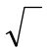 | sqrt | put sqrt(16)
Exponents | ( )# | **# | put 3**4
Quotient |  | div | put 12 div 7
Remainder |  | mod | put 12 mod 7

More examples for displaying numbers and numeric expressions:

Code | Output | Notes
put^5 | 5 | integers
put^25 | 25 | integers
put^34.789 | 34.789 | real
put^4*3 | 12 | evaluates expression and prints answer
put^8+2-3 | 7 | evaluates expression and prints answer
put^38.4:10:2 | ^^^^^38.40 | field width and number of decimals
put^5:4:1 | ^5.0
put^546.23:2:1 | 546.2 | rounds off; ignores field width (too small)

Note:
- a number and numeric expression is evaluated not duplicated
- field width: spaces = fieldwidth - number of characters including decimals
- numbers are right aligned within field width
- if field width is too small, it is ignored

Integers and Real Numbers

Integers do not have a decimal point. So far, all of our programs involve integers. Now it is time to deal with real numbers.

put 4/3 (Result is 1.333333) *The number has a decimal point, therefore it is a real number. Integers have no decimal.
put 2/3 (Result is 0.666667) *It rounds the number off, otherwise 6 would be infinite.

*In case you don't want numbers to show after the decimal, use the div command.
put 4 div 3 (Result is 1) *This command cuts off all digits after the decimal point.

Arithmetic Expressions

put 5 + 6 * 3 (Result is 23)

With such expressions the computer uses precedence rules to determine the answer.
The computer calculates multiplication and division, before addition and subtraction.
Say only addition and subtraction commands were indicated, the computer performs the calculations from left to right.

Same thing if only multiplication and division were indicated.
In order to control the precedence you can use parenthesis in the expression.

put (5+6) *3 (Result is 33) *Computer calculates expressions in brackets before anything else.

The precedence of the computer can be remembered by BEDMAS
B - brackets
E - exponents
D - division
M - multiplication
A - addition
S - subtraction

Combining Calculations and Messages

put "2+2=", 2+2 (Result is 2+2=4)
Messages in quotes are displayed exactly as typed.
Output of a Series of Items

You can output a list of items by separating them with a comma.
put 2+5, 3*7, 5-2 (Result is 7213)

There are two ways in which we can space out the answers to each problem.
put 2+5, " ", 3*7, " ", 5-2 (Result is 7 21 3)

Another way to do this is to give a field size.
put 2+5 : 5, 3*7 : 5, 5-2 : 5
Result = ^^^^7^^^21^^^^3 (The ^'s aren't really displayed. They just represent blank spaces required)

Displaying a combination of information

To combine different types of info in one print statement - use a comma
Examples:
Code | Output | Notes
put^5,”85”,24.2:3:1,”\n5*2” | 58524.2  5*2
put “8*8=^“,8*8 | 8*8=^64

